Freight Assessment System (FAS) DEV Support Guide



**Prepared By**

Soft Tech Consulting, Inc.

4229 Lafayette Center Dr., Suite 1700

Chantilly, VA 20151

Table of Contents

Revision History 2

1. Purpose 3

2. Support Procedures 3

2.1 Obtaining Access 3

2.2 Software Info 3

2.3 FAS Application Server Information 3

2.4 Bring up DDD 3

2.5 Setup Environment Variables 4

2.5.1 JAVA_HOME Variable 4

2.5.2 ANT_HOME Variable 6

2.5.3 JBOSS_HOME Variable 7

2.6 Checkout Code using Git 7

2.6.1 Install Git and TortoiseGit Client Tools 7

2.6.2 Add a generic credential 7

2.6.3 Git Config 7

2.7 Application Build Process 8

2.7.1 Install Maven 8

2.7.2 Build the WAR file 9

2.8 Application Deployment Process 10

# Revision History

|  |  |  |  |
| --- | --- | --- | --- |
| Doc. Version | Date | Author | Summary |
| 1.0 | 04/10/2018 | Tracy Ho | Initial Version |

# Purpose

This document is a guide for new user who will be supporting the FAS application.

# Support Procedures

## Obtaining Access

Visit this URL for information regarding the DTE accounts

<https://office.ishare.tsa.dhs.gov/sites/CSCITIP/dteitesp/SitePages/DTEGettingStarted.aspx>

## Software Info

| Software Name | Location |
| --- | --- |
| JBoss EAP 6.4.0 | Y:\jboss-eap-6.4* |
| JDK 8u162 | Y:\JDK\jdk-8u162* |
| Oracle SQL Developer v 3.1.07 | Z:\Included\SqlDeveloper3.1* |
| WinSCP v 4.3.7 | Z:\Included\winscp437* |
| PuTTY v 0.67 | Z:\Included\putty-0.67* |
| ant-1.9.6 | Y:\ant-1.9.6* |

*Note: Y: Drive is the shared drive on DDD file server (\\SDCZAFSWDAV032\DEV-Team-Shares\stci\Softwares\)

Z: Drive is the shared drive on DDD file server (\\10.100.112.32\DDDTools\)

## FAS Application Server Information

|  |  |  |  |  |
| --- | --- | --- | --- | --- |
| DTE DEV | | | | |
| Server Name | IP Address | Purpose | OS / Server Details | Software Installed |
| K021B-6128 | 10.253.202.148 | App Server | Solaris | JBOSS EAP 6.4  Sun Java JDK 1.8 |
| K021B-6153 | 10.253.202.149 | App Server | Solaris | JBOSS EAP 6.4  Sun Java JDK 1.8 |

## Bring up DDD

* Open this url <https://office.ishare.tsa.dhs.gov/sites/CSCITIP/dteitesp/default.aspx> in web browser
* Select the ‘***DTE DDD/Tester Access Link***’ in the Quick Links on the left. You will receive the popup message below. Click on the ‘Open’ button.



* Click on the ‘Connect’ button when you see the popup window below

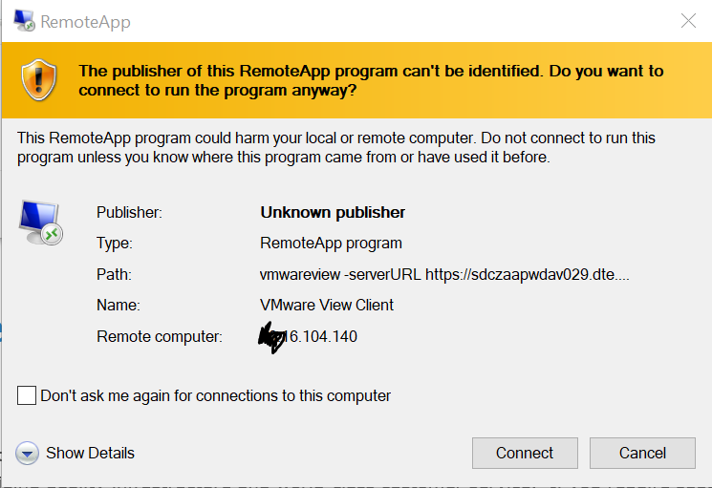

* Enter your DTE password and click on ‘OK’ button

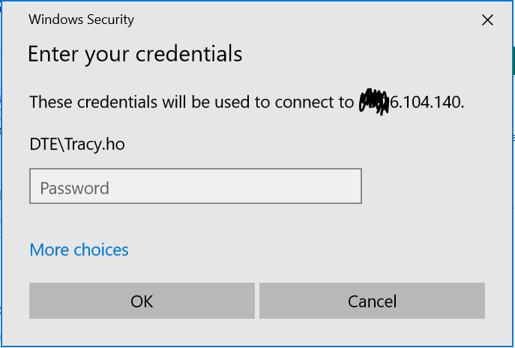

* Click on ‘OK’ button when you see the disclaimer message screen
* Select the cloud icon in the ‘***VMware Horizon Client***’ window

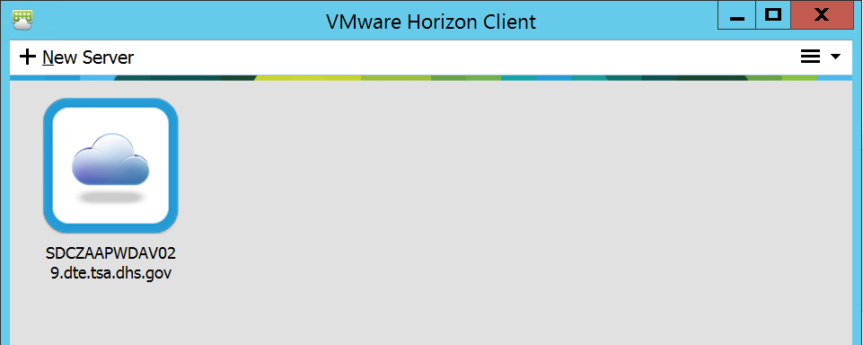

* Windows 7 DDD is opened

## Setup Environment Variables

### JAVA_HOME Variable

To set the JAVA_HOME variable on Windows

1. Choose Start 🡪 Control Panel, and double-click the System icon.
2. Click the Advanced tab, and then click the Environment Variables button.
3. Under System Variables, select New to create the JAVA_HOME environment variable.
4. Set the variable name to JAVA_HOME and the variable value to *install-dir***\java-version** and click OK.

For example, the installation directory might be **C:\Program Files\Java\jdk1.8.0_162**

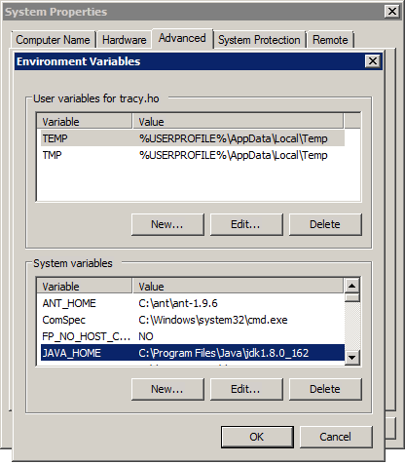

1. Select the **PATH** environment variable and select Edit.
2. Add **%JAVA_HOME%\bin** to the PATH.
3. Click OK and then click OK again.

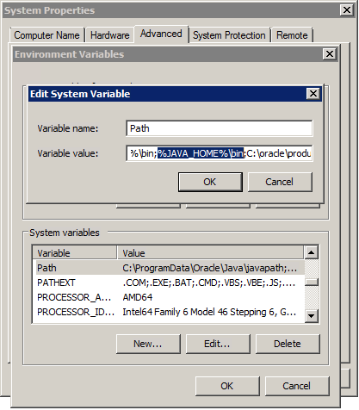

1. Open a **command** prompt. Type **java -version** and press Return. Then type **path** and press Return. Check that the **version** number **1.8.0_162** matches in both **java –version** and **path**. Oracle updates **Java** periodically and you might have a more recent **version**.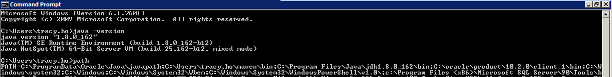

### ANT_HOME Variable

To set the ANT_HOME variable on Windows

1. Choose Start 🡪 Control Panel, and double-click the System icon.
2. Click the Advanced tab, and then click the Environment Variables button.
3. Under System Variables, select New to create the ANT_HOME environment variable.
4. Set the variable name to ANT_HOME and the variable value to *install-dir***\ant-version** and click OK.

For example, the installation directory might be **C:\ant\ant-1.9.6**

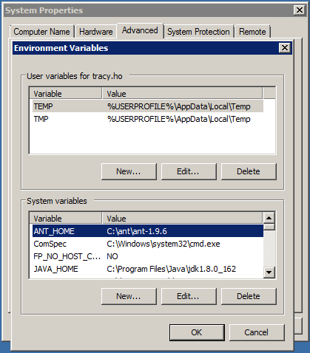

1. Select the **PATH** environment variable and select Edit.
2. Add **%ANT_HOME%\bin** to the end or beginning of the PATH.
3. Click OK and then click OK again.

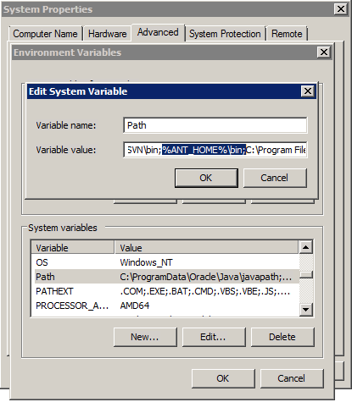

1. To test the setting, type **ant** at a command prompt and press Return.

If a Build not found error message appears, you have correctly installed Ant.

If you do not see an error message, check the environment variable settings and make sure they are pointing to the correct directory locations.

### JBOSS_HOME Variable

To set the JBOSS_HOME variable on Windows

1. Choose Start 🡪 Control Panel, and double-click the System icon.
2. Click the Advanced tab, and then click the Environment Variables button.
3. Under System Variables, select New to create the JBOSS_HOME environment variable.
4. Set the variable name to JBOSS_HOME and the variable value to *install-dir***\jboss version** and click OK.

For example, the installation directory might be **C:\jboss-eap-6.4\jboss-eap-6.4**

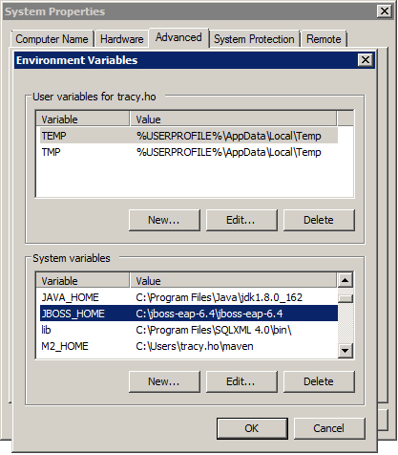

## Checkout Code using Git

### Install Git and TortoiseGit Client Tools

* On your DDD navigate to this directory \\SDCZAFSWDAV032\DEV-Team-Shares\cae
* Copy these files to your DDD and run the installer for each:
* Git-2.11.0-64-bit.exe
* TortoiseGit-2.5.0.0-64bit.msi

### Add a generic credential

* Open **Control Panel** and select the **Credential Manager**
* Click on the ‘Add a generic credential’ in the **Generic Credentials** with the information as below
* Internet or network address: ***git:https://collabnet.tsa.dhs.gov***
* User name: ***Your Collabnet username***
* Password: ***Your Collabnet password***
* Click ‘OK’ to save

### Git Config

1. Create a local folder to host the FAS Git repo.
2. Launch the Command Prompt
3. At prompt, use “cd” command to navigate to the dir created in step 1
4. Run the following command, using your CollabNet user name instead of mine

*git config --global user.name “Tracy_Ho”*

*git config --global user.email “tracy.ho@tsa.dhs.gov”*

*git config --global http.sslVerify false*

1. Run the following command, using your CollabNet uid instead of mine (when prompted for uid and pw enter your CollabNet credentials)

*git clone* [*https://tracy_ho@collabnet.tsa.dhs.gov/gerrit/fas_git*](https://tracy_ho@collabnet.tsa.dhs.gov/gerrit/fas_git)

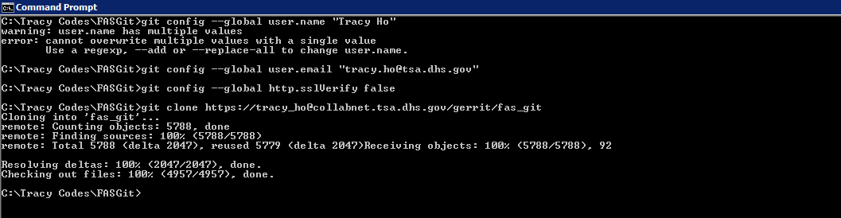

## Application Build Process

### Install Maven

1. Download Maven’s zip file on [Apache](https://maven.apache.org/download.cgi), and unzip it to the directory you wish to install
2. Create M2_HOME and update PATH variables
   1. Add M2_HOME variable in the Windows environment, and point it to your Maven folder

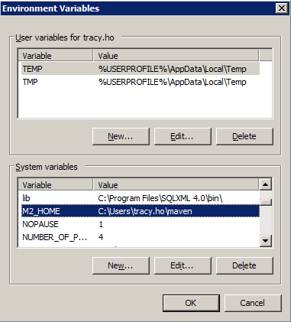

* 1. Update PATH variable, append Maven bin folder - %M2_HOME%\bin, so that you can run the Maven’s command everywhere.

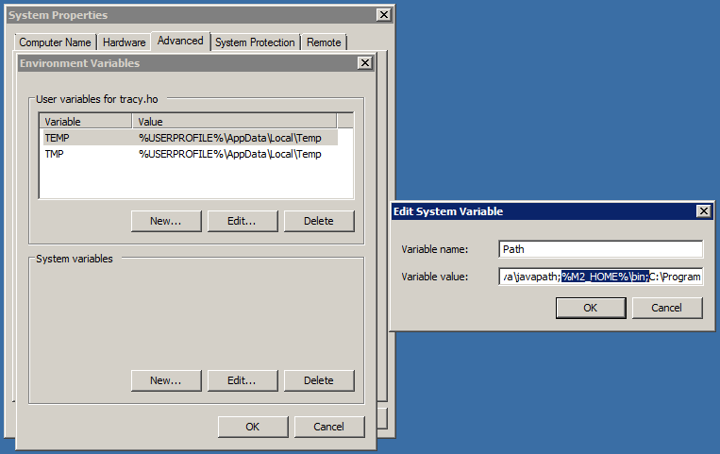

1. To verify maven, run mvn –version in the command prompt

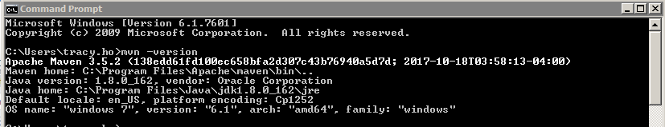

### Build the WAR file

1. Change to \src\NX-folio in the command prompt.



1. Run the "mvn clean" in the command prompt.

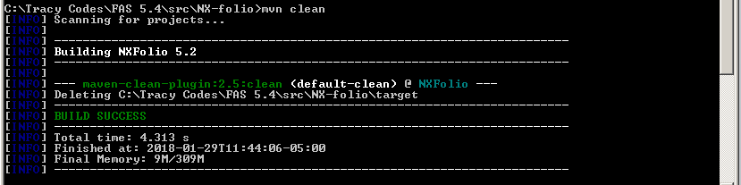

1. Run the “mvn package” in your project folder where *pom.xml* file is placed. This will execute the maven “package” phase.

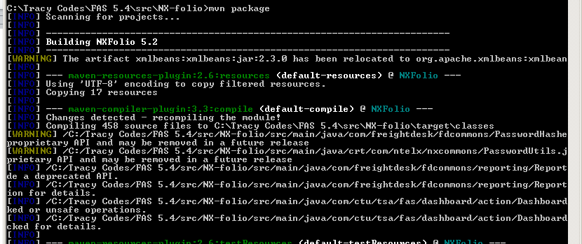

1. Change the directory to \src\NX-folio\target. The **NXFolio.war** file is built and saved in there.

## Application Deployment Process

|  |  |
| --- | --- |
|  | *This deployment is done on your local* |

* Copy the *NXFolio.war* file from your local repo (it should be under /src/NX-folio/target/) to the deployments folder in jboss-eap-6.4



* Run the *standalone.bat*

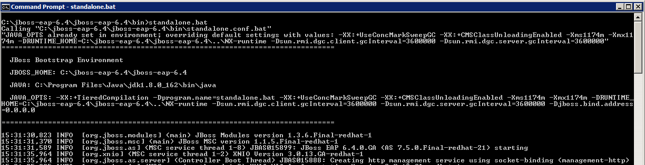

* After the build is done. Enter <http://localhost:8080/logon.jsp> in the IE browser, you should see the FAS login page displayed as below

